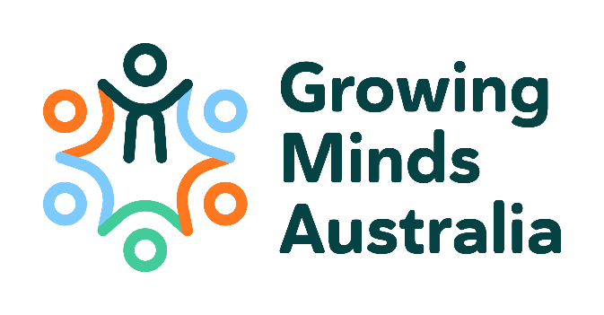
EMCR Research Fund 2023/24 (draft)

The mission of Growing Minds Australia (GMA) Clinical Trials Network (GMA-CTN) is to conduct clinical trials research to improve outcomes in child and youth mental health. GMA-CTN is multidisciplinary and aims to assess a broad range of treatment interventions and management strategies to improve outcomes in child and youth mental health.

In line with GMA’s strategic plan, the Early-Mid Career Researcher (EMCR) Research Fund has been established under guidance from the Steering Committee and Scientific Advisory Committee, to support EMCR members in the development of investigator-initiated studies, and for us to learn about how a clinical trials network may benefit our members. The studies may be trials, infrastructure that may support trials, or research that may ultimately lead to trials. A total of $200,000 (inclusive of GST) is available, which may be split across multiple projects and/or recipients. Eligible research projects may include:

- GMA pilot studies (including generating data to support a larger GMA clinical trial);
- Translational research that may lead to a larger GMA project;
- Infrastructure proposals which made available sustainable support to research projects;
- Seed funding to start a high priority GMA study that has a high likelihood of receiving ongoing funding from another source.

Not all funds may be awarded in the first round with any remaining funds available for ad-hoc grants or a second round of applications, at the discretion of the GMA Steering Committee following guidance from the GMA Scientific Advisory Committee (GMA SAC).

Eligible research projects will:
- Be consistent with GMA’s mission and objectives and include a budget justification up to AUD$200,000 (inclusive of GST);
- Involve endpoints that are feasible within a 1-2 year time frame;
- Be expected to build capacity and/or collaborations for GMA and have the potential to lead to future GMA projects.

The successful recipient will be required to:
- Be a GMA-CTN member and an active contributor to GMA activities;
- Acknowledge GMA’s contributions towards ongoing development and any associated outputs of the funded research;
- Acknowledge GMA in any publications or presentations as a result of the award;
- Attend relevant meetings to provide updates on the project and present final report to the GMA Scientific Advisory Committee;
- Provide a formal written report at the completion of the project to GMA;
- Provide a summary report for use in GMA publications;
- As this research fund is supported by MRFF funds, successful recipients must ensure that any university administrative costs are not taken out of this grant.

Assessment and notification

A grant review panel will be appointed by the GMA SAC to assess each application. Within the framework of the above requirements, the following specific criteria will be used as part of the review and selection process:

a) A plan detailing how collaboration ensures that this is a network-developed and supported project;
b) Quality of science;
c) Evidence that amount of funding applied for is used to seed advancement with further funding;
d) Strength of research team with minimum 2/3 team requirement for early-mid career researchers;
e) Demonstration that study accords with the mission, vision and values of GMA and its Terms of Reference;
f) Consideration of health economics, research translation, lived experience inclusion and statistical consultation (core methods);
g) Evidence of the extent this study avoids duplication with existing studies.​

Written feedback will be provided to applicants across the categories of scientific merit/knowledge gain, research team strength, and feasibility, as well as general comments.

There will be three workshops as a part of the development of this grant application round:

- Workshop 1 – Consultation on the criteria above – help us develop a supportive review process (11 October 2023 at 11am)
- Workshop 2 – Bring some seed ideas to generate shared insights on feasibility (late October 2023)
- Workshop 3 – Support for shaping up to present the proposal(s) to the GMA ASM in March 2024 (late January – early February 2024).

Successful applicants will receive their grants in the period following the Growing Minds Australia Annual Scientific Meeting which will take place February 29 – March 1 2024, in Manly, Sydney, Australia.

Key dates
11 Oct 2023 Workshop 1
30 Oct 2023 Workshop 2
Nov 2023 Grant applications open
21st December 2023 Grant applications close
End Jan 2024 Initial review rounds complete & notification
Late Jan 2024 Workshop 3
(potential practice Zoom presentations to Growing Minds Australia groups)
Early March 2024 ASM presentation

Award decision follows ASM presentation, and any project proposal adjustments required and submitted for approval to the GMA SAC.

Please complete the Research Fund Grant Application Form below and email to: growing-minds-australia@sydney.edu.au by COB WHEN.
If you have any questions regarding the application process, please contact Executive Officer at growing-minds-australia@sydney.edu.au.
Endorsement Application and Project Description Form
Please ensure your application is no longer than six (6) pages in total. Note that the review panel will be multidisciplinary in composition, and the ability of non-expert reviewers to easily comprehend all aspects of the application should be carefully considered.
Email your completed application to growing-minds-australia@sydney.edu.au by the closing date (DAY DATE MONTH YEAR).

Project title:
Date of submission:
Chief Investigator name:
Discipline: | Organisation:
Telephone: | Email:
Lay summary for community engagement advisory review/public communication [maximum 300 words]
Suggested headings:

Background and rationale (including theory):
Aim:
Objectives (endpoints):
Primary
Secondary
Tertiary/correlative
Hypotheses:
Population and setting:
Assessment/Prevention/Interventions:
Study design:
Outcomes and measures:
Study procedures:
Statistical considerations:
Feasibility (track record and timeline):
Significance/avoidance of duplication:
Risks:
How is this project aligned with GMA’s Terms of Reference, goals and objectives?
Please describe the translation plan:
Describe how this project may lead to future GMA studies?
Key members of research team (list brief details only but include name, discipline and organisation). Research team must be GMA members.
Detail for the early career researcher advancement strategy in this proposal/ study committee formulation:
Have you applied for, or are you receiving, funding from other organisations for this project? |  | ☐ Yes ☐ No
If yes, who and for how much?
Which organisation will be responsible for administering the grant funds?
Address and contact details of organisation administering the grant funds:
Has approval been granted by the organisation to support this project? |  | ☐ Yes ☐ No
Will the organisation charge a fee or overhead? **If yes, this must be specified in the detailed budget, and coverage for it must be provided from a distinct source, not the GMA grant |  | ☐ Yes ☐ No
Project duration (months)
Proposed deliverables including publications, and timeframe
Total requested funds (Maximum Research Grant is $200,000 including GST) |  | $
Detail how health economics and stakeholder consultation are addressed in this proposal:
Detail regarding how this funding would support overcoming barriers traditionally in place with respect to trial size and quality:

Budget justification
Budget excluding GST | Year 1 | Year 2
Staff (list) | $ | $
Consumables | $ | $
Site costs (specify) | $ | $
Other | $ | $
Total | $ | $

Other pertinent details (1-2 pages)

